Report on Way Forward Seminar
Integrating tobacco cessation within the TB programme

Date:14.10.2019
WAY FORWARD SEMINAR/WORKSHOP
Date: 17th September 2019
Venue: (Ramada, Islamabad)

PARTICIPANT LIST TB & TOBACCO WAY FORWARDING SEMINAR 17-09-2019
SR | NAME | DESIGNATION | ORGANIZATION
1 | Aamina rashid | Program Manager TB Program | Mercy Corps
2 | Dr. M Khalil Akhtar | Deputy Chief | HSRU, Health Secretariat
3 | Dr. Zakir Hussain | PM PTP | DoH, GB
4 | Abdullah | Manager Data | CMU, ntp
5 | Dr. M Dost Khan | MDR | PTP, KPK
6 | Noman | Planning Officer | Health Department, KPK
7 | Nusrat Waheed | Research Officer | NTP
8 | Shahzad Alam |  | WHO
9 | Quaid Saeed | Grant Manager | CMU
10 | Mudassar Mushtaq | AP | HAS
11 | Dr. Amna Ali | RO | NIH
12 | Aashifa Yaqoob | Bio-Statistician | NTP
13 | Dr. Razia Kaniz Fatima | Chief Research | CMU
14 | Dr. Ejaz Qadeer |  | PIMS
15 | Paul Nunn | Director | GIDC
16 | Saima Saeed | Pulmonologist | Indus Hospital
17 | Julie Pekowski | M&E Lead | USAID
18 | Dr. Zohaib Khan | Director | ORIC, KMU
19 | Dr. Safat Ullah | Research Associate | ORIC, KMU
20 | Dr. M. Umar | Research Officer | HAS
21 | Dr. Ghafoor | NTA | NTP
22 | Dr. Fakhra |  | NTP
23 | Dr. Raheel | S.M.O | FG TB Hospital RWP
24 | Dr. Hazoora Shaikh | Director PTP | PTP, Sindh
25 | Dr. Syed Saleem | SPPO | PTP, Sindh
26 | Dr. Minhaj us Siraj | DDG Health | M/O NHSR&C

Objectives of the Seminar
- To present the TB and Tobacco Project, Trial and Qualitative study to Federal and Provincial Policymakers
- To share the experiences of scaling up tobacco cessation support within the TB programme in Khyber Pakhtunkwha Province
- To present testimonial from field on video (actual TB patients who were smokers but have since quit-success story)
- To give a call to action – participants to identify next steps in the workshop? i.e. To plan for the integration of tobacco cessation within routine TB care in each province

Time | Presentation | Presenter
9:00 to 9:30am | Registration
Opening  9:30-9:40 am | Keynote | National Coordinator  CMU Dr Rana Safdar
9:40-10:10am | Introduction on TB and Tobacco trial and scale Up | Dr Razia Fatima
10.10am-10:30am | TB and Tobacco Project-Brief summary emphasis on Behavioural support (BS) | Dr Amina Khan
10.30-11:10am | Qualitative and Trial results (brief summary)) | Helen Elsey  University of York
 | Working Tea
11:10-1140am | KP scale up presentation-WP6 | MD/ZK
11.400-12:10am | WP6 scale results | HE/MD/ZK
12:10-1225pm | Call to Action- What steps we want the government to take for Country Scale up | Dr Razia  Fatima chief Research NTP.
12:25-12:40pm | Policy brief | Dr Razia/Helen
12.40-01:00pm | Q&A session | Moderator AK
1:00-1.20pm | Address of Chief Guest
1.20-1.25pm- | Thank you note | Dr Razia Fatima
1:25-2:10pm | Lunch

Materials:
- A policy brief had been prepared with the support of the University of York. The brief had been shared with all the participants
- The first TB Tobacco video had been shown during the session

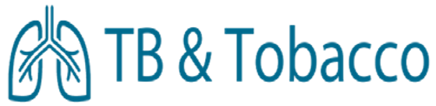
Policy Brief: Integrating tobacco cessation within the TB programme: findings from the ‘TB & Tobacco’ study

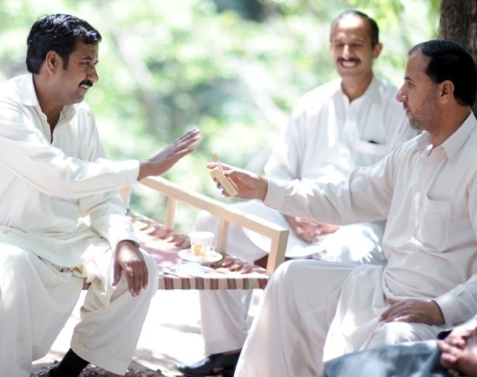
Key Messages
In Pakistan, 20% of all adult (30% of men) TB patients smoke regularly. Smoking doubles their risk of death due to TB. Overall, tobacco causes 20% of all TB deaths.
To help them quit, DOTS facilitators can deliver brief counselling using a simple flipbook to TB patients as part of their routine work. With this support, approximately one-third of all TB patients can quit smoking by the time they finish their TB treatment.
Those who quit have significantly better TB outcomes than those who don’t.
Based on 2017 notification figures, if brief cessation support was delivered to all those over 15 years old with TB, this would enable over 13,000 patients across Pakistan to quit tobacco use every year.
Achieving these impressive outcomes will cost the programme just 348 Pakistan Rupees per patient helped to quit.
In a pilot, tobacco cessation integration was scaled up in 59 public and private facilities in Khyber Pakhtunkhwa (KP) Province. Following a brief three-hour training delivered by trained NTP staff and using our freely available videos, DOTS facilitators felt 86% confident to deliver cessation counselling. In the six months since January 2019, they have identified and counselled over 7% of TB patients (14% of men) to quit and collected data on tobacco in routine TB forms.
The National Strategic Plan (NSP,2016-2020) recognizes the need to integrate tobacco cessation. It is recommended that the specific activities needed for tobacco cessation integration are included in the next National Strategic Plan.

TB and Tobacco in Pakistan
The link between TB & Tobacco: According to the Global Tuberculosis Report (WHO, 2018) 5% of the estimated 10 million people who contracted TB disease in 2017 reside in Pakistan. We know that 15% of TB disease burden can be attributed to tobacco.
“Initially, I was feeling uninterested in all what he was saying thinking that these are not suitable things to talk about in front of everyone. But later when I felt relaxed at my heart that if I would avoid using these things, I will gain health and this and that, then I was relaxed. Then I liked it.” Female patient, 25 years old

From infection to outcome, tobacco is negatively associated with TB. Tobacco smoking almost doubles the risk of TB infection, tobacco users are more than twice as likely to develop active TB. Tobacco causes worse cavity lesions and tobacco users take longer to convert to sputum negative and are more than twice as likely to die from TB than no-users.
The GATS Pakistan is the first national survey on tobacco in adults, and it shows that overall prevalence of tobacco use was 19.1%. Based on a sample of more than 5,000 TB patients, our recent study found that 20% of all adult TB patients (30% of all males) in Pakistan smoke tobacco on a regular basis. The GATS survey shows a decreasing trend of tobacco use in Pakistan that should be taken as a good sign indicating better awareness in the masses and stronger implementation of anti-smoking laws.
Our Research
The first smoking cessation trial in Pakistan - Action to Stop Smoking in Suspected Tuberculosis (ASSIST), conducted between 2010 and 2012, assessed behaviour support delivered to patients suspected of TB by TB health professionals. In this trial, 41% of patients were able to quit tobacco use after 6 months with behaviour support alone; smoking-cessation medication ‘bupropion’ provided no significant additional benefit.
In a recently concluded trial in Bangladesh and Pakistan, we recruited 2472 TB patients who smoked on a regular basis. While they all received a brief (about 8 minutes) behavioural support session delivered by TB health workers, half also received a relatively cheap smoking-cessation drug ‘cytisine’ while the other half received placebo. Approximately one-third of all TB patients that took part in the trial stopped smoking at 6 months. A vast majority of those who stopped smoking remained abstinent even after 12 months; cytisine did not offer much additional benefit. These results were based on biochemical tests, not just patients’ word.
Our study shows that short and simple counselling by TB health professional in routine care can help almost a third of TB patients who smoke to quit.
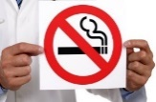
For those patients who were able to quit, there was a significant improvement in their scores of TB signs and symptoms from baseline (BL) when they were diagnosed with TB and received the counselling.
Impact of Quitting on TB signs and symptoms
By helping people with TB to quit, TB health professionals can help their patients to recover from their TB, live healthier lives and reduce TB in Pakistan.
Based on 2017 TB notifications, if everyone diagnosed with TB in Pakistan was supported to quit by their DOTS facilitator, every year over 13,000 TB patients would quit tobacco, and significantly improve their TB outcomes.
“There is a lot of difference, Earlier, I didn’t know all those things. I had an idea that tobacco is a dangerous substance but not this much. I’ve only come to know after this training how dangerous it is”. DOTS facilitator from the private sector in KP.

Scaling-up Tobacco Cessation in Khyber Pakhtunkhwa Province
Revising TB Forms
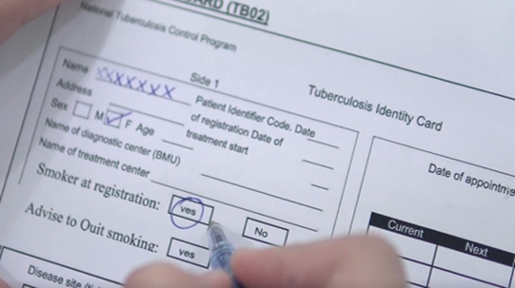
TB forms 01, 02 and 03 were revised to include the following 3 columns:
- tobacco status at registration,
- advice given
- quit at the 6 months.
We collected data on the revised forms from January to June 2019. DOTS facilitators in KP didn’t find collecting this data a burden: “We can do this work without any hesitation. It is not something very detailed we just simply have to tick mark the options whether the person is a smoker”

Building on the impressive quit rates achieved in these two trials, we joined forces with the provincial TB programme in KP to evaluate a 6 month scale up of cessation support. We identified strategic changes to the health system to overcome the identified barriers, namely:
- policy change,
- a training of trainers and roll out of a brief training for health workers
- revision of supervision guidelines to include monitoring of provision of cessation,
- the inclusion of three key indicators within recording and reporting forms (see box)
These strategies were piloted in 59 facilities in 4 districts in KP. The provincial programme trained 10 trainers (5 doctors and 5 DOTS facilitators) in a one-day training session.
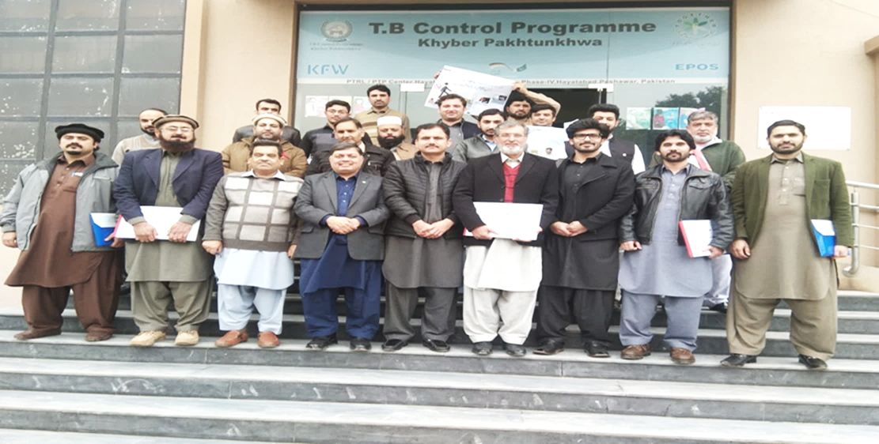
Training of trainers in KP Province
These trainers then went on to train 55 doctors and 56 DOTS facilitators and 4 data assistants across the 4 districts. The 4 district training sessions were kept short and simple, using our training videos and only taking between 3 and 4 hours. We assessed their confidence to deliver cessation support before and after training and found their confidence scores went up to 86%.
Between January and July KP programme recorded the data from the revised TB forms. DOTS facilitators were able to identify and support 7% of all TB patients and 14% of male TB patients to quit tobacco. The data on the revised forms will ultimately allow KP
Identifying and supporting TB patients in KP to quit | Number of Facilities | All TB patients >15 years | % of male smokers identified and supported to quit
Abbotabad | 9 | 851 | 29%
Kohat | 10 | 580 | 13%
Mardan | 12 | 1081 | 9%
Peshawar | 28 | 2577 | 12%
Total | 59 | 5089 | 14%
Province to see the proportion of TB patients who are able to quit and to support their staff to deliver effective support to help tobacco users to quit smoking

Recommendations
- National Strategic Plan (NSP,2016-2020) mentions the integration of tobacco cessation. It is recommended that details of TB Tobacco integration should be included in the next National Strategic Plan.
- Each Province develops action plans to integrate tobacco cessation into the routine work of the TB programme, with a focus on:
  - Training trainers who can roll-out tobacco cessation training to DOTS facilitators
  - Revising TB reporting forms to include the 3 measures of i) tobacco status, ii) advice and iii) quit at 6 months
  - Revising supervision checklists and guidelines to include tobacco cessation

All materials are freely available:
All materials including flipbook, leaflet, posters, health worker guide and training slides and videos are available in Urdu and English: https://tbandtobacco.org/. You will also find our research papers showing the evidence behind the cessation strategies.

Objectives of the working group exercise:
- To invite provincial policymakers to develop ownership for behaviour support program at provincial level
- To articulate a problem statement (TB and Tobacco) and present it to the provincial policymakers
- To encourage provincial policymakers to find solutions to the problem in the context of their province.
Forming 5 working groups: (KP Policymakers will act as Facilitators along with the TB and Tobacco Team)
  - Punjab Group-
  - Sindh Group
  - Balochistan Group
  - Azad Kashmir Group
  - Gilgit Baltistan Group
  - ICT group

Each group will constitute 2 provincial policymakers and Member of TB and Tobacco team as facilitator,
Time | Activity | Responsibility
2.10-2.45pm | Read out the Problem statement and ask working members to discuss solution after the two planned exercises.  EXC1:What are the facilitators and barriers regarding implementation of BS for tobacco cessation in your province (template on A4 sheets will be provided) | AK/ZK/MD/RZ
2.45-3.40pm | EXC2: Devise an action plan to maximize facilitators and minimize barriers in your province.(template will be provided) | AK/ZK/MD/RZ
3:40pm | Working tea
3.40-4.30pm | Presentations and discussion  Each working group will make a presentation to the larger group and answer questions of the group
 | Closing Remarks | Dr Razia Fatima

BRIEF DISCUSSION POINTS- TB AND TOBACCO WAY FORWARD MEETING
17-09-2019 PAKISTAN

BARRIERS.

-Smoking is a way of socializing in South Asia, hence a very challenging issue.
-Tobacco industry very influential and LMIC are economically dependent on their taxes.
-National tobacco guidelines in place but not implemented in true spirit.
In the public sector
-DOT’s facilitators are already overworked so separate counsellers need to be hired.
-For the health workers (doctors, nurses paramedics) there is no routine training on tobacco cessation and no material available.
-No coordination of TB program and national tobacco control in the past.
-Within the TB programme there is poor coordination.
-The major barrier is lack of resources due to less global fund allocated to TB programme recently.
-Tobacco cessation not being the priority for the politicians so not many resources allocated for this purpose.
-Gender imbalance at the DOT’s level.
In the private sector
-Being unregulated-difficult to ensure 100% implementation of the guidelines
-Time constraint on part of GPs
a. They spare very less time for patients’ counselling
b. They are reluctant to spare time for longer duration trainings
-No separate counselling space at private clinics
-HR Shortage
-Shortage of financial resources

FACILITATORS
-Pakistan is the signatory of FCTC.
-Teachable moment: For TB patients, being healthy is a priority and are very sensitive to any information which is crucial in their struggle to get better.
In the public sector
-The NTP with PTP in Pakistan has a very strong infrastructure in place. This integration and coordination within the programme will be very beneficial for TB patients and for embedding tobacco cessation (BS).
-Asking Smoking status of TB patients is already a part of NSP of National TB Programme.
-Findings from TB and Tobacco study that BS improves the TB outcomes are very encouraging. Least number of messages within minimum amount of time required for training like In KPK proved that eight minutes of counselling can improve TB outcomes in a very cost-effective way.
-The pilot in KPK where R&R tools with added questions about smoking status and quit date proved very beneficial.
In the private sector:
-Availability of tobacco legislation and guidelines on tobacco cessation
--MC’s(Mercy corp) geographical presence across the country
-MC’s experience of engaging private sector providers
- MC’s experience of community engagement
- MC’s close coordination with NTP, PTP and other key stakeholders at national, provincial and district levels

ACTION PLAN to minimize barriers and maximize facilitators

1. EXISTING RULES AND REGULATIONS:

- Smoking status needs to be a part of PSP as it is in NSP.
- Advocacy with key stakeholders at national, provincial and district levels for enforcement of tobacco cessation legislation and guidelines. Multi-sector action plan and advocacy at the highest level should be in place. The National TB control program can take the initiative to form a steering group with all stakeholders included from public and private sector. Its purpose should be advocacy at the highest level(national assembly, senate and standing committees.). For this steering group a chairman can be nominated. For advocacy, IEC material should be disseminated to the parliamentarians
- Formation of Technical Working Groups (TWGs) at provincial level for advocacy. For this technical group each province can nominate a focal person to be a part of this technical advisory group this will enable to link together for research activities, support activities and coordinate.
- Dr RAZIA to be nominated as the focal person from the NTP

. 2 TRAINING:

- Incorporate tobacco cessation in training DOTs and of private sector general practitioners and during their quarterly review meetings
- Training of implementing partners and field staff

3 REVISION OF R&R TOOLS
- This is at NTP and PTPs level –private organization will support this.
- R&R (Reporting and Recording tool) TB01, TB02,TB03 and TB07 forms should be revised as in KPK province.All provinces to be informed of development and information to shared across the board. Get their consensus on revising the R&R tools.
4 SUPERVISION:
- Existing M&E system is strong and effective
- Revision in M&E checklists and reporting tools
5 RESOURCES:
- Both human and financial resources will be required for additional activities and need to have a multisectoral approach.
6 OTHERS:
- National Tobacco control cell and TB programme to integrate and coordinate in working together for tobacco cessation in TB patients.
- Contact investigation of smokers and their contacts for TB
- Dr Razia to be nominated as the focal person from the NTP

