[Inside Fold] **Tobacco Products & Their Harmful Ingredients**

Nicotine, which is addictive, is present in all tobacco products. But there are many more dangerous ingredients present in different products. Continuing to use these products makes recovery more difficult and increases chances of getting TB again.

Tobacco Product

Tobacco Product

Tobacco Product

Tobacco Product

Rat poison

Amonia/ detergents

Pesticide/fertilizer

Batteries (Cadmium)

CO exhaust fumes

Batteries (Cadmium)

CO exhaust fumes

Rat poison

Amonia/ detergents

Pesticide/fertilizer

Paint (Lead)

[Back]

Picture of supportive Friends/Family/Etc

You should be proud to make the step to quit tobacco and get the support of your friends and family in helping you to become tobacco free!

[Quotations from patients or messages on abrupt cessation, saving money from quitting tobacco, importance of family support, encouragement that relapse is common and keep trying to quit]

**You can get tobacco cessation support at your TB Clinic. Ask a health worker about how we can help!**

[Front]

Picture From Main Poster Showing Happy patient and Health Worker

**Recover from TB!**

**Quitting Tobacco Helps you Get Better!**

**Quit Tobacco Today!**

TB is curable with medication, but tobacco use can decrease your chances of recovery. You can become somebody who quits tobacco for good! Find out more inside this pamphlet!

[Inside Left] **What is TB?**

TB is mostly an airborne disease. The bacteria spread from person to person in tiny droplets when a person with TB coughs or sneezes. Only people with active TB can spread the disease to others if they are around them for extended periods of time. TB **IS** **NOT** spread by sharing food or utensils.

You **MUST** take your medicine regularly for six months. Soon after beginning the treatment, you will no longer be able to transmit the disease. Taking your medication regularly will cure you of TB.

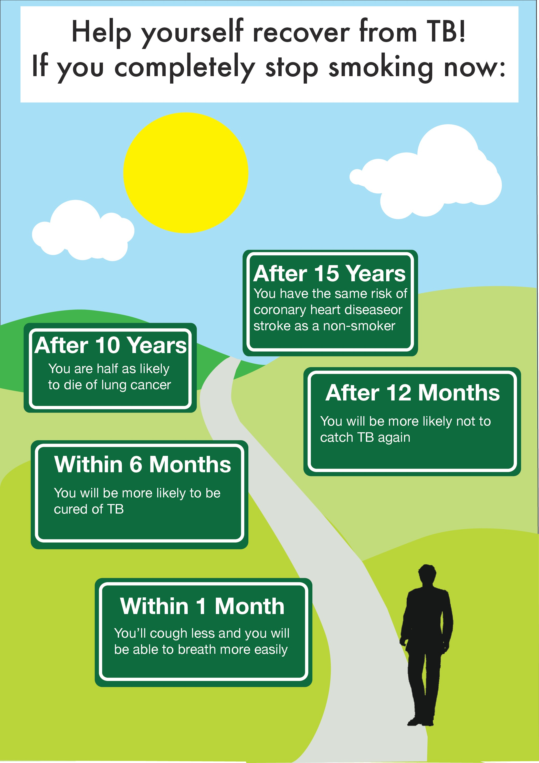

[Inside Centre]**Possible Effects and How to Address Them**

After quitting tobacco you might experience some brief side effects. These will go away quickly. Here are some possible effects and how to address them:

|  |  |
| --- | --- |
| Picture for Craving for tobacco | * Stay away from other smokers * Keep calm and take deep breaths. The craving will end in few minutes * Sit in a quiet place and drink water * If you are in your home then lie down in a quiet place * If you are at work then take a five minutes break, and rest in a quiet place * Take some alternative (like chewing gum, aniseed) * **Remind yourself the benefits of smoking cessation and feel proud** |
| Picture for Irritation and short temper | * Avoid crowded and noisy places * Avoid arguments * Sit in a quiet place and drink plenty of water * If you feel stressed due to work, take a break * After smoking cessation, indulge yourself in some activity (like reading books or newspapers, watching movies, listening to music etc.) * **Remember that smoking is not the solution of your problems, it creates problems** |
| Picture for Headache | * You may get headache few days after stopping cessation tobacco but it will start getting better within a week * Take some tablet (like Paracetamol) for headache * Take green tea /Qhuwa |
| Picture for Acidity and constipation | * Remember that these are temporary problems; in fact smoking itself causes acidity and constipation * Go for a short walk after taking meal * Increase fruits and vegetables consumption in your diet, it will lead to better health * **If you are having severe acidity then consult doctor and take medications for it** |
| Picture for Feeling of fatigue and lack of concentration at work | * During break time, buy fruits from the money you saved from smoking cessation and eat them * Take tea to increase your concentration * **Take proper rest daily so that you do not feel fatigue** |
| Picture for Cough | * Remember it is not a serious issue. After quitting smoking, sputum production in lungs increases, cough happens to clear that sputum * This cough will be relieved in two to three weeks. **If you are having severe cough then consult your doctor and take some cough syrup** |

[Inside Right]

**How can you Quit Smoking**

It can be hard to quit smoking but lots of people with strength and courage have succeeded in quitting smoking.

* First you need to make a plan to quit.
* Decide a day to quit
* Tell your family members that you are about to quit so that they can help you in quitting
* Cigarette, water pipe (hookah) & other forms of tobacco things must not be put at home
* Spend the money you save from quitting smoking on other better things

Change your routine and make yourself busy.

Here are examples of some ways you can address the desire to use tobacco [Include text under pictures]

